 | Aspire to Achieve  December 2024 |  |  | 
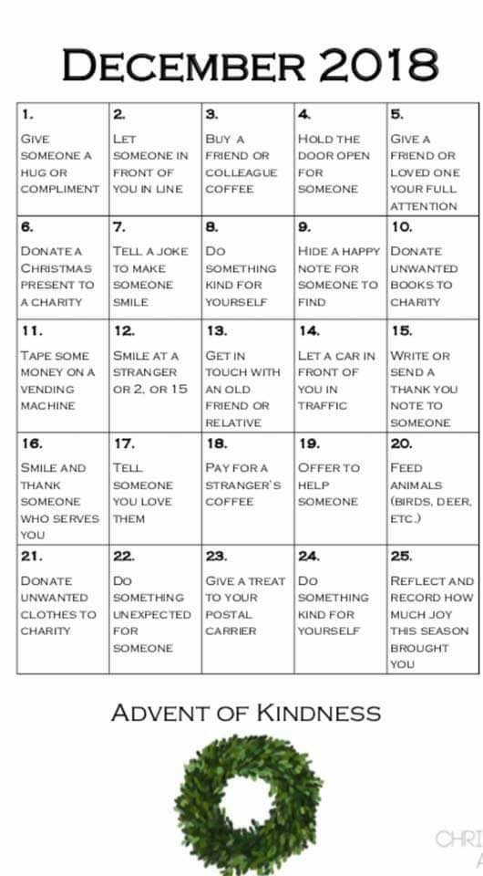
Respect Responsibility Relationships

‘Our School has a Mind to be Kind’

